InkFluence

Project Report

**Submitted by**

Fardos Hasan Roton

1903166

Dept. of Computer Science & Engineering

RUET

**Submitted to**

A. F. M. Minhazur Rahman

Lecturer

Dept. Of Computer Science & Engineering

Rajshahi University Of Engineering and Technology

A Book Recommendation and Review Website

Ferdous Hasan

Software Development Project-II

CSE 3200

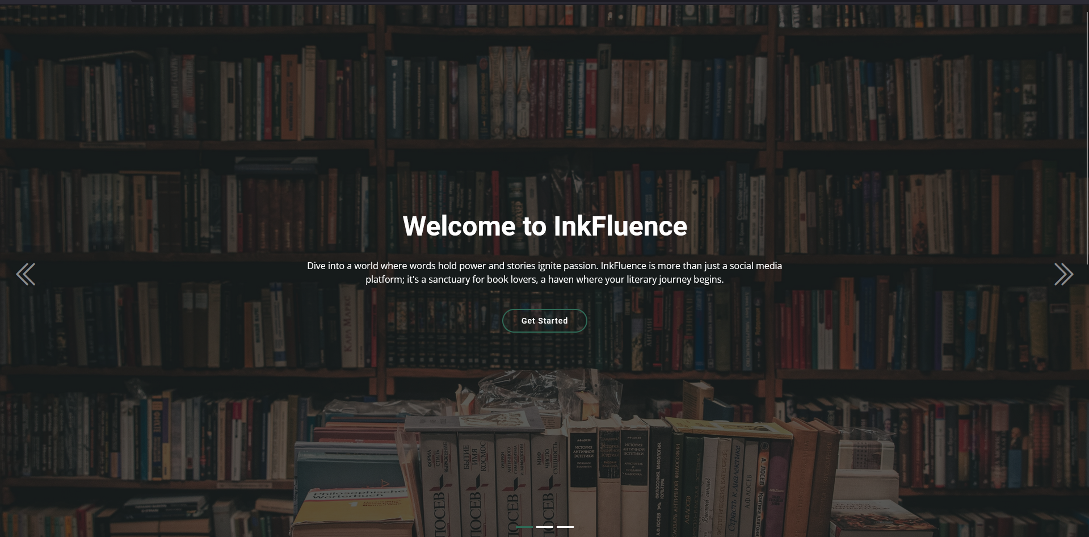

INKFLUENCE

Navigating Literary Tides with Words that Inspire



**Table of Contents**

* What is InkFluence? 03
* Features 04
* How to get started? 05
* Home Page Personalization 06
* Home Page 07
* Book Details, Reviews & Recommendations 08
* Book Preview 10
* Community 11
* Write a Review 11
* Profile 12
* Used Programing Language 13
* Database 13
* Used API 13
* Used Software 13
* Future Enhancements 13
* Conclusion 14

**What is InkFluence?**

InkFluence is a dynamic online platform designed to cater to the needs of book enthusiasts seeking inspiration and organization in their reading pursuits. At its core, InkFluence serves as a vibrant community hub where users can connect with fellow bibliophiles, discover new literary gems, and manage their reading lists with ease.

The platform's main theme revolves around two key features: book suggestions and a personalized tracker. Through sophisticated recommendation algorithms and user input, InkFluence provides tailored book recommendations based on each user's reading preferences, past favorites, and genre interests. This ensures that users receive personalized suggestions that resonate with their individual tastes, fostering a deeper connection to the books they discover.

In addition to book suggestions, InkFluence offers a convenient tracker tool that allows users to organize their reading lists efficiently. Users can categorize books as "to read," "currently reading," or "already read," providing them with a digital library to manage their literary endeavors. This feature enables users to stay organized, track their reading progress, and curate their own virtual bookshelves with ease.

Overall, InkFluence aims to empower users to explore, discover, and engage with books in a meaningful way. By fostering a supportive community of book lovers and providing valuable tools for book discovery and organization, InkFluence strives to be the ultimate destination for bibliophiles to connect, thrive, and celebrate their love for reading.



**Features**

Here's a list of features that InkFluence offers:

1. **Personalized Book Recommendations**: InkFluence provides personalized book recommendations based on users' reading preferences and interests.
2. **Community Engagement:** Users can connect with fellow readers, share book reviews, and engage in discussions within the vibrant community.
3. **User Profiles:** Users have customizable profiles where they can showcase their favorite genres, reading history, and contributions to the community.
4. **Live Book Search:** The platform features a live book search functionality that allows users to easily find and select books they want to explore.
5. **Reading Tracker:** Users can track their reading progress, mark books as read, and organize their reading lists efficiently.
6. **Wishlist:** Users can create a wishlist of books they want to read in the future, keeping track of titles they're interested in exploring.
7. **Book Previews:** InkFluence provides preview links to allow users to sample the content of books before making a decision to read or purchase.
8. **User Reviews:** Users can write and share reviews of books they've read, providing valuable insights and recommendations to the community.

These features collectively create an immersive and engaging experience for users, fostering a thriving community of book lovers on InkFluence.

**How to get started?**

To get started on their literary journey with InkFluence, users can simply click on the "Get Started" button. This will take them to a new page where they'll find two options:

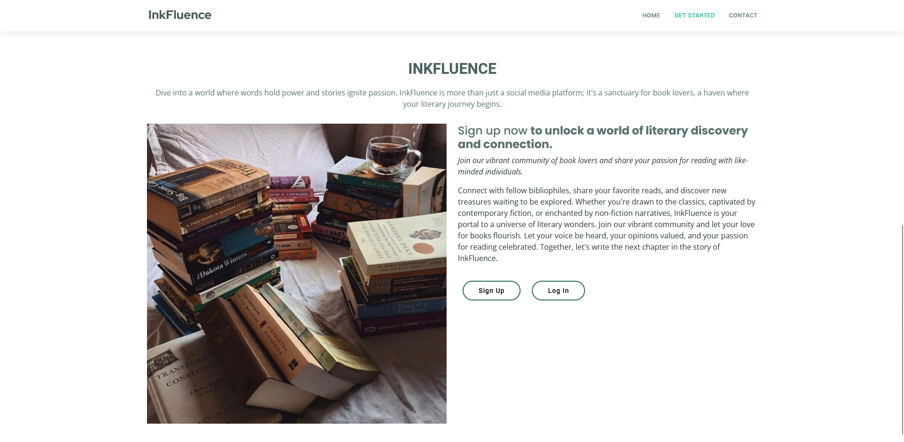

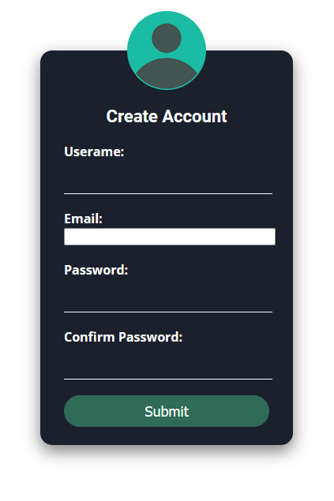

**Sign Up**: If the user is new to InkFluence, they should click on the "Sign Up" option to create their account. They'll be guided through a quick and easy registration process, where they'll provide some basic information and set up their account preferences. Once their account is created, they'll have full access to all InkFluence's features, including personalized book recommendations and a convenient reading tracker.

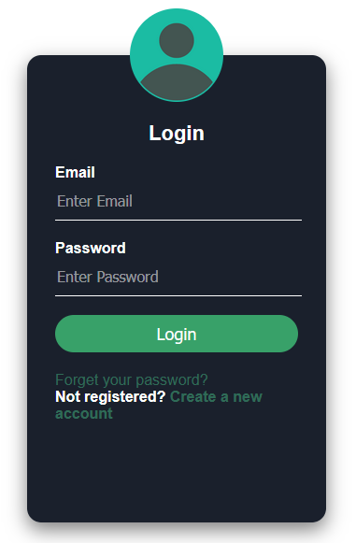

**Login:** If the user already has an InkFluence account, they should simply click on the "Login" option. They'll be prompted to enter their username and password to access their account and dive right into the world of books.

"Books are uniquely portable magic."

-Stephen King

Whether the user is a seasoned bookworm or just starting their literary journey, InkFluence welcomes them to join our community of passionate readers. Click "Get Started" now to embark on an exciting adventure filled with books, discovery, and connection.

**Home Page Personalization**

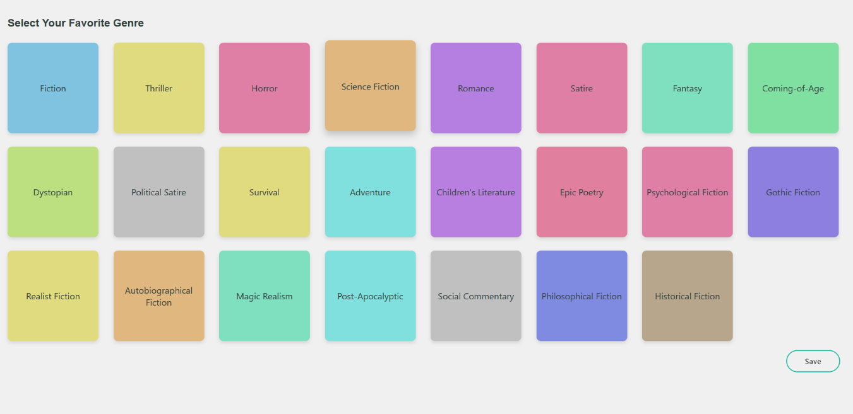After signing up, users will be redirected to a personalized page where they can select their favorite genres. This step allows them to tailor their InkFluence experience to their specific literary tastes.

This personalized bookshelf will feature titles that align with their preferences, making it easy for users to discover new reads that resonate with their interests. With this tailored approach, users can dive into the world of books with confidence, knowing that they're exploring titles handpicked just for them.

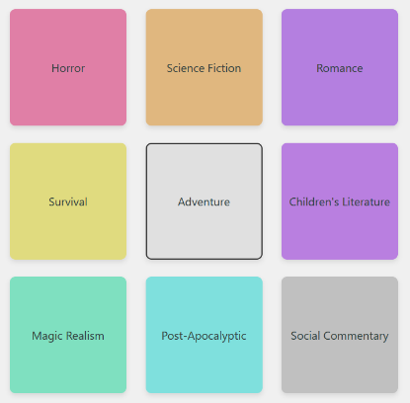

**Home Page**

The homepage of InkFluence is meticulously designed to provide users with a personalized and engaging experience in their literary journey. Here's a detailed description:

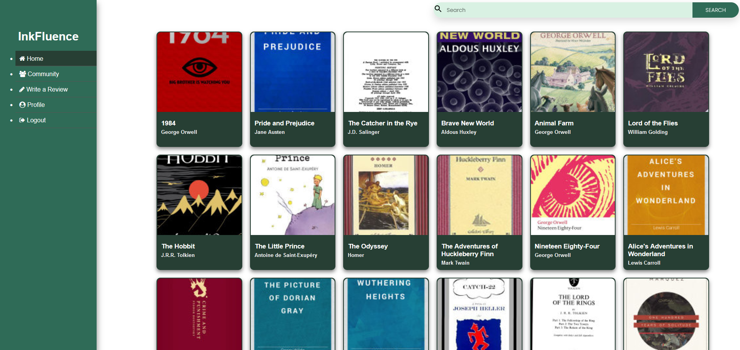

**Title**: Positioned at the top left corner of the webpage is the distinctive title "InkFluence," serving as a beacon for users as they embark on their exploration of the platform.

**Navigation Bar**: A vertical navigation bar adorns the left side of the page, offering convenient access to essential sections of the website. Users can effortlessly navigate between Home, Community, write a Review, Profile, and Logout, ensuring a seamless browsing experience.

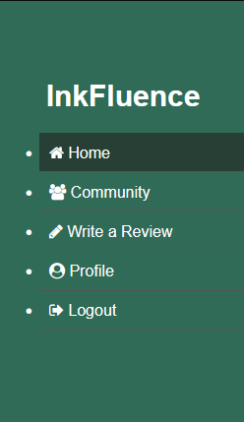**Main Content Area**: The heart of the homepage lies within the main content area, where a thoughtfully curated grid layout showcases a collection of books tailored specifically for each user. This personalized selection is meticulously crafted based on the user's preferences and interests, aiming to captivate and inspire them in their literary pursuits. Each book cover within the grid is clickable, providing users with access to more detailed information, reviews, and discussions about the suggested titles.

**Search Bar**: Positioned at the top right corner of the page is a user-friendly search bar, empowering users to explore the vast universe of literature within the platform. Whether seeking specific titles or authors, the search feature enables users to navigate with ease and discover new literary treasures.

**Book Details, Reviews & Recommendations**

When users click on a book name on the homepage of InkFluence, they are directed to a detailed page dedicated to that specific book. Here's a comprehensive description of what users can expect to find:

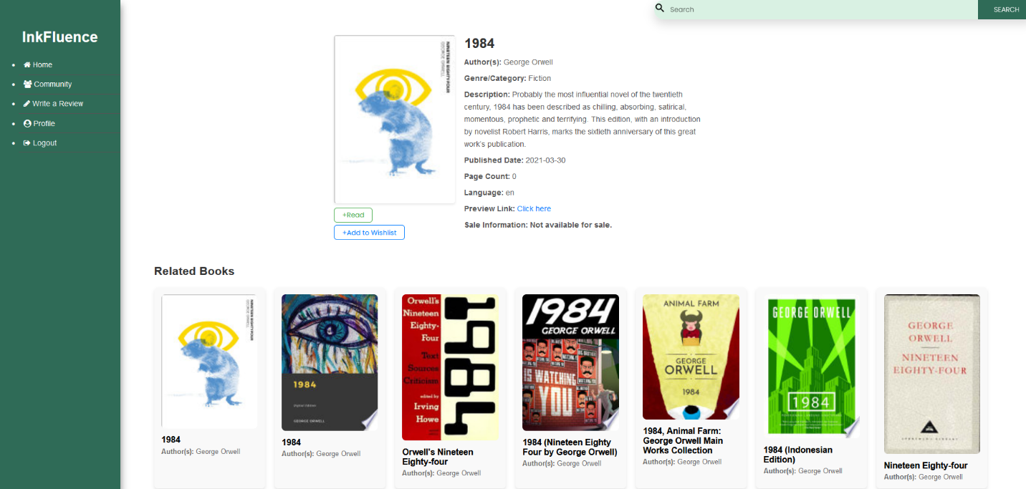



**Book Title:** The title of the book is prominently displayed at the top of the page.

**Author:** Shows the name of the book's author.

**Genre/Category**: Identifies the thematic focus or genre of the book, helping users understand its content and style.

**Description:** Provides a succinct overview of the book's plot, themes, and characters, offering users a glimpse into what to expect.

**Published Date:** Displays the date when the book was released, offering users context about its publication history.

**Language:** Specifies the language in which the book is written, ensuring users are aware of the linguistic characteristics of the work.

**Preview Link:** Offers users a link to access a preview or excerpt of the book, allowing them to sample its content before making a decision.

**Sale Information:** Provides details on how the book can be purchased, including pricing and purchase options, for users interested in acquiring the work.

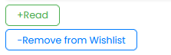**Action Buttons:** Includes buttons labeled "Read" and "Add to Wishlist," allowing users to take immediate actions such as reading the book or saving it for later.

**Related Books:** Showcases additional book recommendations related to the selected book, helping users discover similar titles of interest.

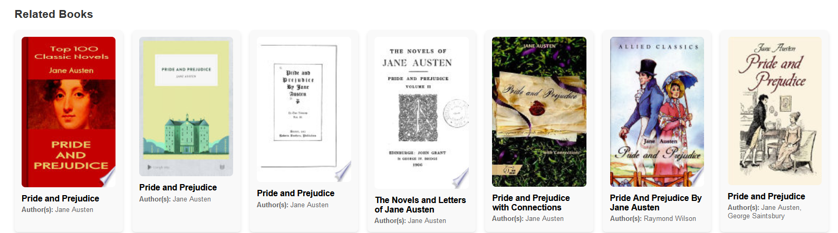

**User Reviews:** Displays reviews and feedback from other users, offering valuable insights and opinions about the book from fellow readers.

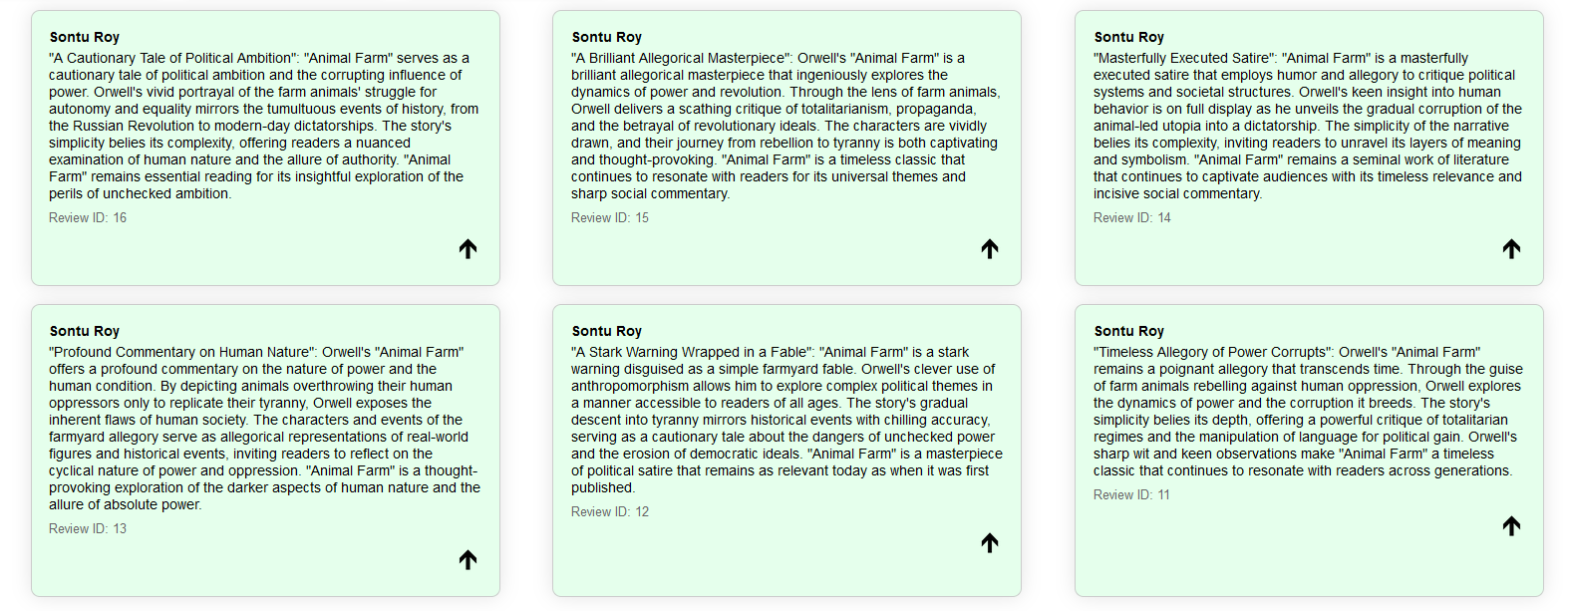

**Book Preview**

Clicking the preview link will redirect users to Google Books, where they can access a preview of the selected book if available. Google Books provides users with the opportunity to browse through a portion of the book's content, allowing them to read a sample of the text and get a sense of its writing style, themes, and overall content.

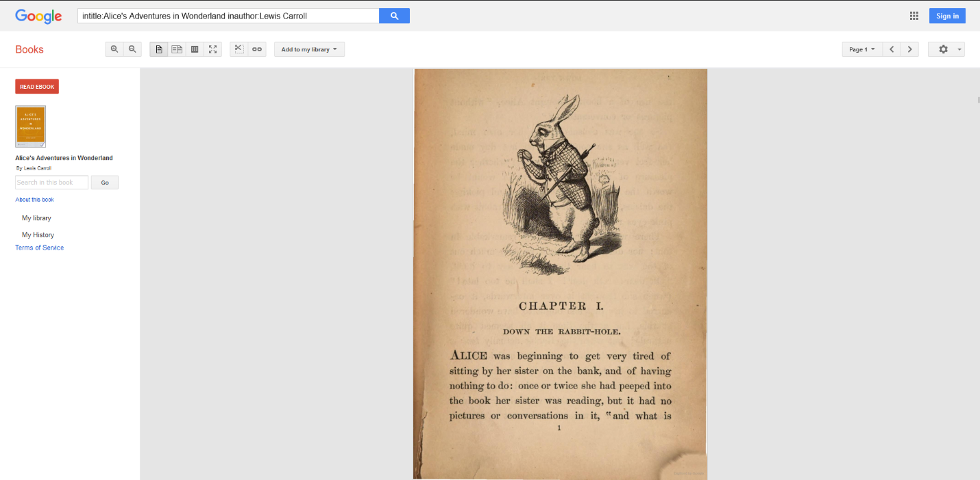

**Community**

The Community page on InkFluence hosts user-generated book reviews, providing concise insights into various titles. Each review includes essential details such as the book title, author, genre, and the username of the reviewer. Users can browse through these reviews, with the option to upvote their favorites.

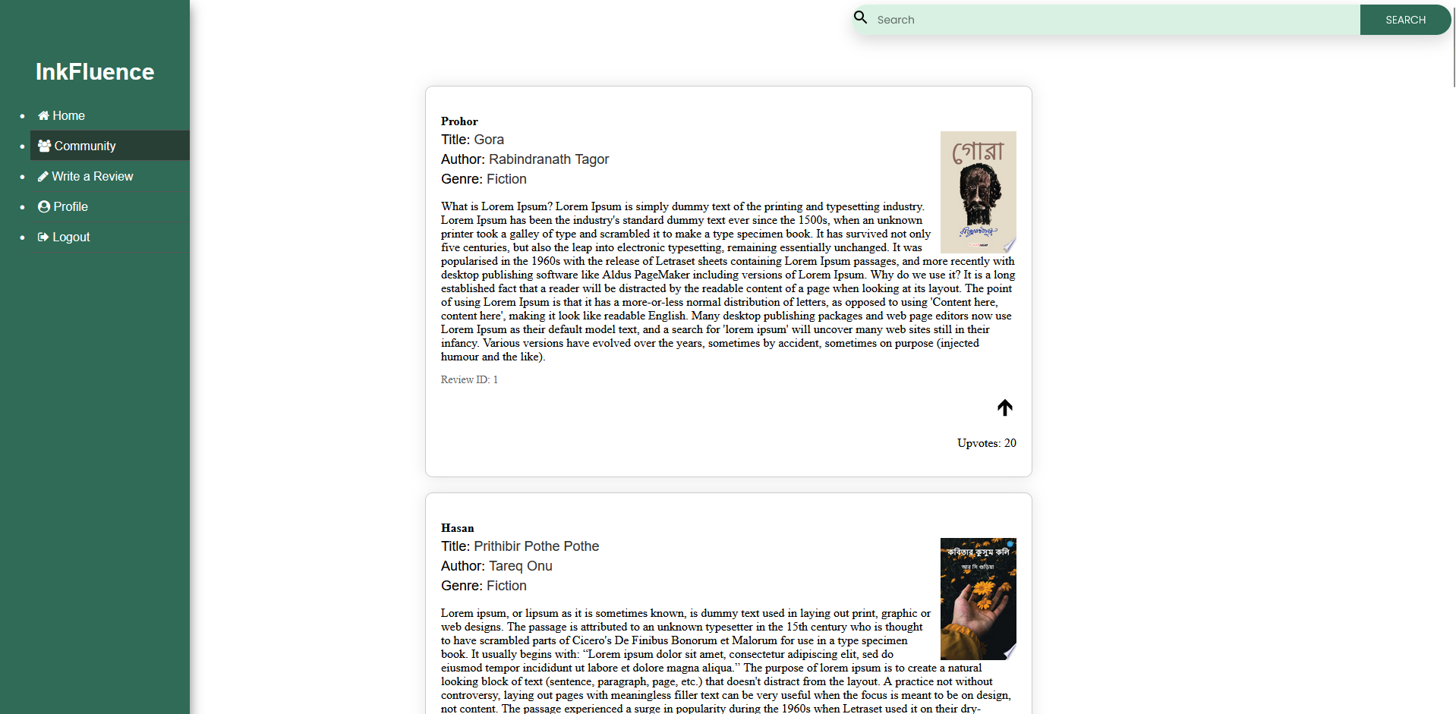

**Write a Review**

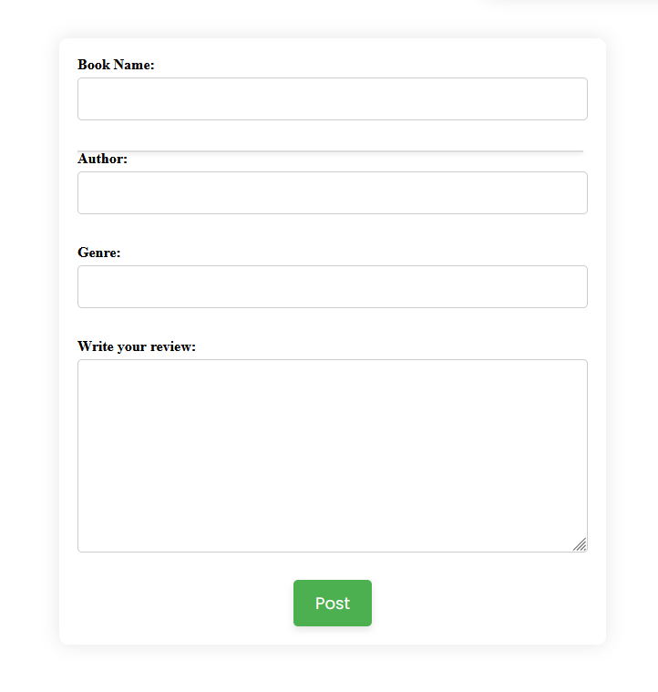The "Write a Review" page on InkFluence features a text area where users can compose their reviews, expressing their insights and reflections on the selected book. As users begin typing the book's name in the designated area, a live search functionality dynamically suggests book titles, facilitating an efficient selection process. Upon selecting a book title, the author and genre information are automatically populated, minimizing user input and enhancing convenience. After completing their review, users can click the "Post" button to publish their contribution to the community.

**Profile**

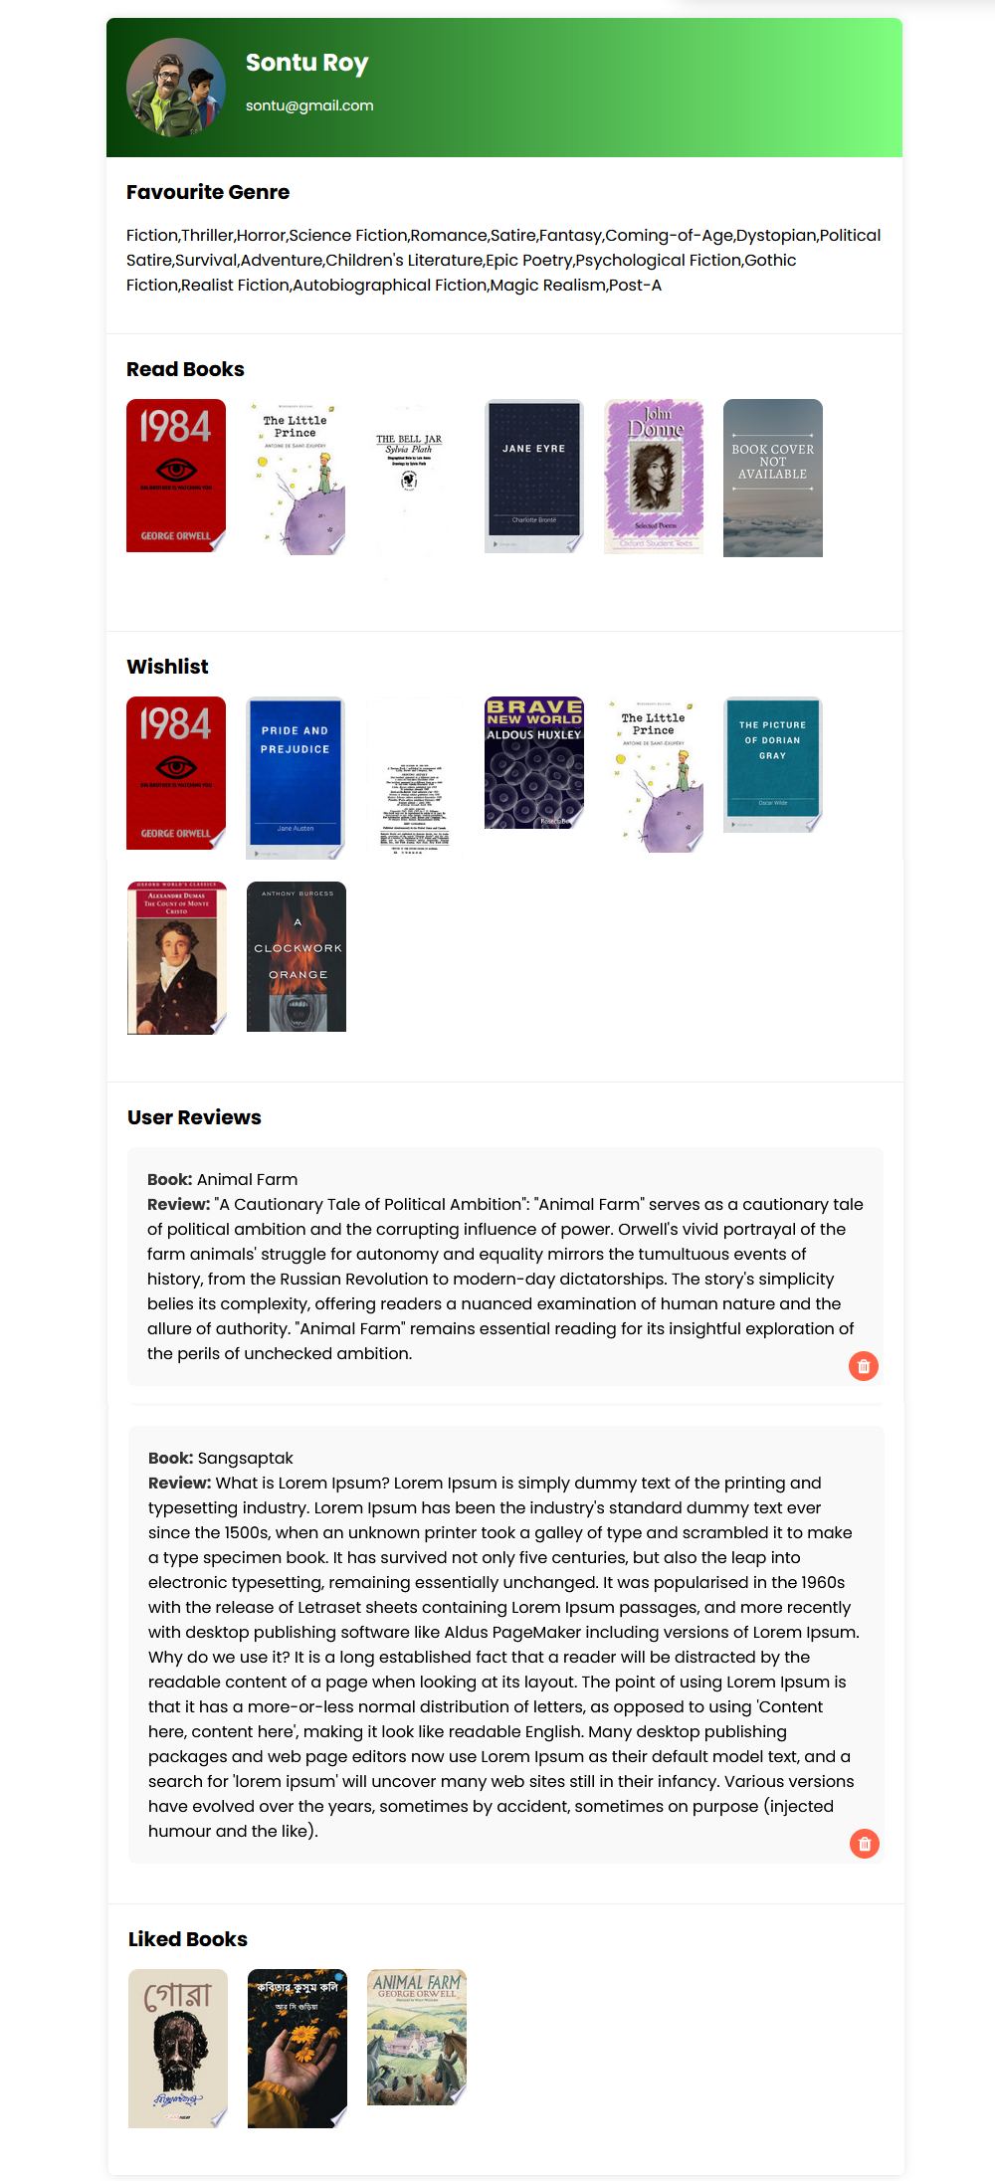The Profile page on InkFluence offers users a personalized space to share their reading preferences and contributions. At the top, users find their profile picture, name, and email for easy identification. Below, the page is divided into sections:

**Favorite Genre:** Users can showcase their preferred literary genres, providing insights into their reading interests.

**Read Books:** This section displays books the user has read, offering a glimpse into their reading history and preferences.

**Wishlist:** Users can list books they wish to read, offering insight into their future reading aspirations.

**User Reviews:** Here, users share their thoughts and opinions on books they've read, providing valuable insights and recommendations.

**Liked Books:** This section showcases books the user has liked.

**Used Programing Language**

* HTML
* CSS
* BOOTSTRAP
* JAVASCRIPT
* PHP
* SQL

**Database**

* MySQL

**Used API**

* Google Book API

**Used Software**

* Visual Studio Code
* XAMPP Control Panel
* Firefox browser

**Future Enhancements:**

Here are some potential future features that will be added to the InkFluence platform:

1. **Advanced Recommendation Algorithms:** We will continuously refine and improve the recommendation algorithms to provide even more accurate and personalized book suggestions for users.
2. **Book Clubs:** We plan to introduce a feature where users can create or join book clubs based on specific genres or themes, facilitating deeper discussions and interactions among members.
3. **Reading Challenges:** We will implement reading challenges and goal-setting features to motivate users to read more and track their progress over time.
4. **Audio Book Support:** We aim to introduce support for audio books, allowing users to listen to their favorite books on the go and catering to different reading preferences.
5. **Enhanced Community Features:** We plan to expand community features such as discussion forums, book recommendation groups, and virtual events to foster deeper connections among users.
6. **Multi-Language Support**: We will offer support for multiple languages to cater to a diverse user base and promote inclusivity within the community.
7. **Integration with E-Book Platforms:** We aim to partner with e-book platforms to integrate seamless access to e-books directly within the InkFluence platform, enhancing the reading experience for users.

These features are planned additions to InkFluence in the future, aimed at enhancing the user experience and expanding the platform's capabilities.

**Conclusion**

InkFluence embodies more than just a platform for sharing book recommendations; it fosters a vibrant community of passionate readers united by their love for literature. Through its user-friendly interface and innovative features, InkFluence provides a dynamic space where users can explore, discover, and engage with books in meaningful ways. Whether through personalized book recommendations, insightful user reviews, or lively discussions, InkFluence empowers readers to connect with like-minded individuals and celebrate the joy of reading together. As a testament to its success, InkFluence continues to inspire and enrich the lives of readers worldwide, shaping the future of literary discovery and discourse in the digital age. Join us at InkFluence, where every page turned is an opportunity to connect, learn, and be inspired.



**InkFluence**